EPR Startup

- Running RCP’s to Heat-up

Starting from cold shutdown condition, RCS is first deborated to about 200 ppm for EOC condition. In PCTRAN we can first select IC18 for P = 0.24 MPa and Tavg = 123.6 C. The core reactivity is about –1.6 % dk/k. Then start all four RCP’s to heat up the RCS. The RCP’s have a combined heat rate of 30 MW. When the charging fills up the pressurizer above 20% covering the heaters, we can turn on the automatic controls of the proportional and backup heaters and open the letdown valve. This starts a long and steady heat-up of the RCS to the operating pressure (15.5 MPa) and temperature (about 303º C).

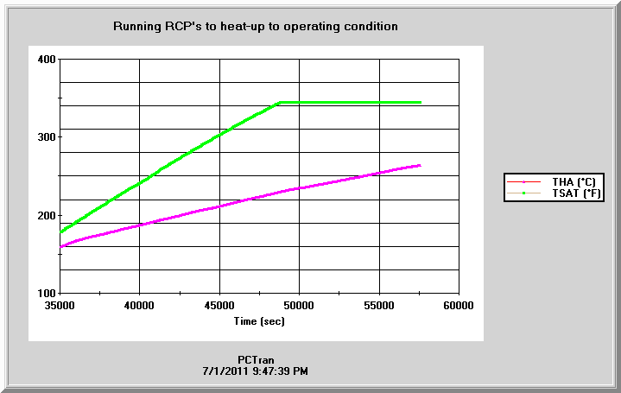
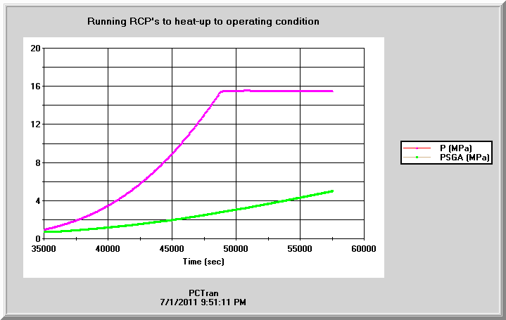

2. Pull Rods to Reach Criticality

When the operating condition of 15.5 MPa and 300 C is reached, we may open both side MSIV’s and one the feedwater pumps. First we’ll use the startup or auxiliary feed pumps and later the main feed pumps. The SG level set point is raised from 35% first to 50%.
Selecting an IC of hot standby condition and start diluting the boron concentration if the reactivity is too negative exceeding the full worth of the control assemblies. The exact amount is cycle-dependent and relies upon the vendor’s technical specifications. Next we shall pull the rod assemblies. First we can do it relatively rapidly till the reactivity in %dk/k approaching to zero. It is the point of “criticality” and adding power into the heat. It is witnessed by the neutron flux in counts per seconds (cps) increase rapidly. There is guideline set by the vendor in decades per minute (DPM) not to be exceeded.

